
Middletown State Veterans Cemetery
Headstone Application - Veteran
Phone (860) 616-3688 or Fax (860) 616-3561

oaa-cms.dva@ct.gov
EXAMPLE

ROBERT C
JOHNSON
LCDR (SS)
US NAVY
WORLD WAR II
SEP 20 1920
JUN 10 2009
SILVER STAR
DEVOTED HUSBAND
DAD AND PAPA
OUR BELOVED BUD
Marble Headstone Inscription Instructions. You may use this form to write-out the inscription you would like on the headstone. Please provide the information to the cemetery prior to the date of the burial. You can email, or fax the application using the information listed above.
There are 11 lines of inscription available on an upright marble headstone. Each block below represents a letter, number or the space between words and numbers. The individual’s name is inscribed on the first two or three lines. The first two lines allow a maximum of 13 characters, including spaces. All other lines have a maximum of 15 characters including spaces. *Items in bold are mandatory on VA headstones. All other items are optional.
When the mandatory portion of the inscription is complete, you may use the remaining lines (9 – 11) to include a personalized additional inscription of your choice, provided it is consistent with our mission to honor Veterans and their families.
** If you use Line 1 for the First Name and Middle Initial in place of the Full Middle Name on Line 2, you may use an extra line at the bottom for Additional Inscription of your choice.
Emblem of Belief (Optional) |  |  |  | Emblems of Belief (EOB) currently offered for inscription at the top of the headstone are depicted on the back of this form. If you wish to add an EOB, please enter the number associated with the EOB.
* 1. | First name w/Middle Initial:  (or use line 2 for full middle name)
2. | ** Full Middle Name:
* 3. | Last Name:
4. | Highest Military Rank:
* 5. | Branch of Service:
6. | War Periods:
* 7. | Month (1st 3-letters)/Day/* Year of Birth:
* 8. | Month (1st 3-letters)/Day/* Year of Death:
9. | Individual Awards of Commendation or Valor: (May be used for Additional Inscription in lieu of awards.)
10. | Additional Inscription:
11. | Additional Inscription:
** Extra line for Additional Inscription:
(This line may only be used if Line 2,
Full Middle Name, is NOT used.)
Next of Kin Signature: |  |  |  |  |  |  |  |  |  |  |  |  |  | Date:

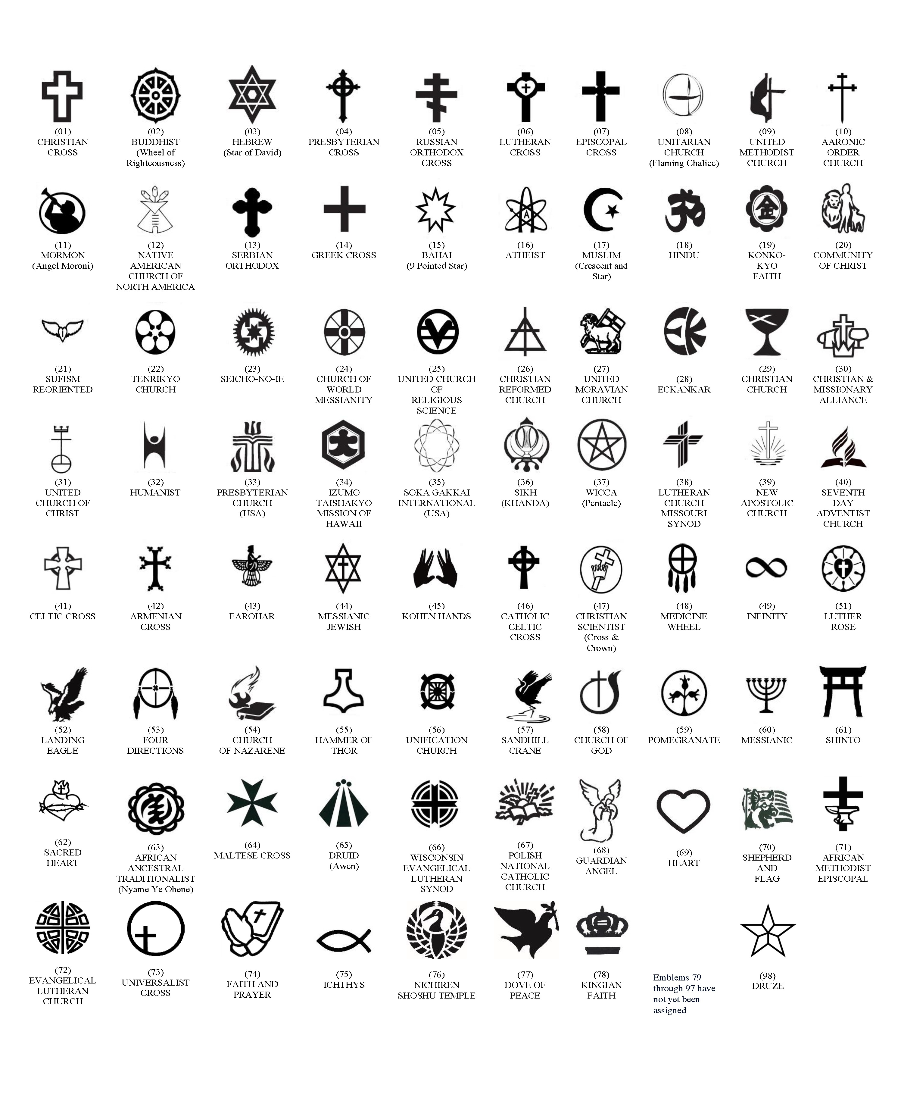
AVAILABLE EMBLEMS OF BELIEF FOR PLACEMENT ON GOVERNMENT HEADSTONES AND MARKERS (As of August, 2022)

